What Should I Read Next?

Check out the following websites for book recommendations and reviews!

 http://www.teenreads.com/

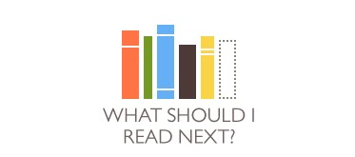http://www.whatshouldireadnext.com

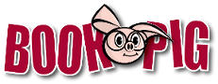 http://www.bookpig.com/Childrens-Books.aspx

 http://www.yournextread.com/us/

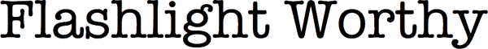 http://www.flashlightworthybooks.com/

 http://www.ala.org/yalsa/booklistsawards/booklistsbook

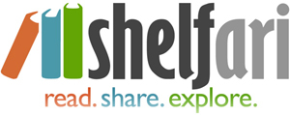 http://www.shelfari.com/

 http://www.goodreads.com/

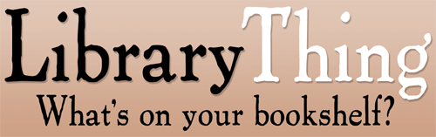 http://www.librarything.com/

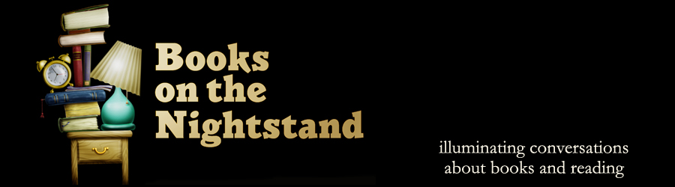 http://booksonthenightstand.com/

